Virginia
Tech
Prepared: July 2015
Updated: March 2020
STROUBLES CREEK
TMDL ACTION PLAN
(2018-2023 MS4 General Permit)

A Plan for Achieving Sediment Load Reductions to Meet the Virginia Tech TMDL Waste Load Allocation

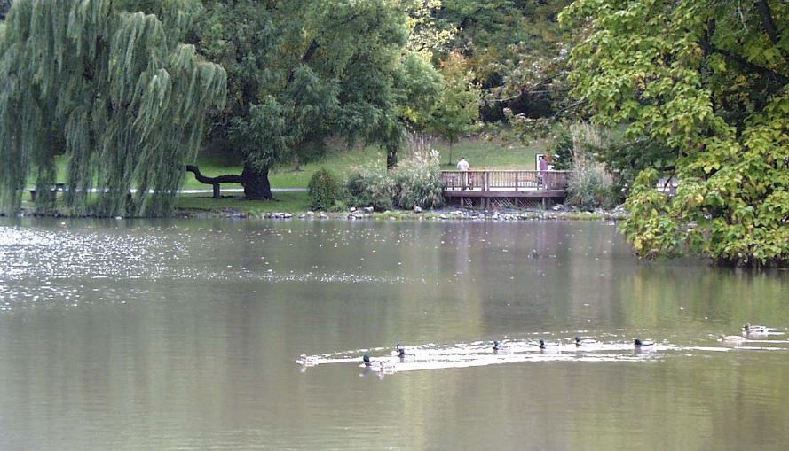

This document satisfies the requirements of Part II.B of the General Virginia Pollution Discharge Elimination System Permit for Discharges of Stormwater from Small Municipal Separate Storm Sewer Systems (9VAC25-890). This document serves as a specific Total Maximum Daily Load Action Plan to identify the best management practices and other interim milestone activities to be implemented to address the sediment waste load allocation assigned to Virginia Tech’s regulated MS4 area in the Benthic TMDL for Stroubles Creek in Montgomery County, Virginia, approved by the Environmental Protection Agency on January 28, 2004.

Executive Summary
Virginia Tech (VT), is authorized to discharge stormwater from its municipal separate storm sewer system (MS4) under the Virginia Pollutant Discharge Elimination System (VPDES) General Permit for Discharge of Stormwater from Small MS4s (MS4 GP). To maintain permit compliance, VT Facilities Services - Site and Infrastructure Development (VT SID) implements a MS4 Program Plan that includes best management practices (BMPs) to address the six minimum control measures (MCMs) and special conditions for the Benthic Total Maximum Daily Load (TMDL) for Stroubles Creek. The Benthic TMDL for Stroubles Creek, approved by the US Environmental Protection Agency (EPA) in 2004, was required to be developed under the authority of the Clean Water Act (CWA) in response to the creek’s listing as impaired by the Virginia Department of Environmental Quality (DEQ) for not meeting water quality standards.

The EPA describes a TMDL as a “pollution diet” that identifies the maximum amount of a pollutant the waterway can receive and still meet water quality standards. In the case of the Stroubles Creek TMDL, sediment was identified as the pollutant of concern and MS4s within the watershed of the impaired segment of the creek were assigned a waste load allocation (WLA). A WLA determines the required reduction in sediment loadings from the MS4s to meet water quality standards and is represented as a 54% sediment reduction in the Stroubles Creek TMDL. The MS4 General Permit serves as the regulatory mechanism for addressing the load reductions described in the TMDL, predominantly through the requirement of a TMDL Action Plan.

Consistent with an approach of MS4s throughout the country to achieve significant sediment load reductions, the presented VT Action Plan identifies street sweeping as the primary practice to achieve the water quality standard described in the TMDL. VT currently owns one street sweeping vehicle and has been sweeping to achieve the targeted sediment reductions for its street sweeping program. The VT Stroubles Creek TMDL Action Plan addresses each of the special conditions described in the MS4 General Permit and prescribes scheduled steps that will be taken to achieve the sediment load reduction target through a defined Street Sweeping Program. Implementation of this Action Plan is consistent with the provisions of an iterative MS4 Program, which constitutes compliance with the MS4 General Permit requirements for reducing pollutants to the maximum extent practicable.
Table of Contents
Executive Summary ii
1.0 Introduction and Purpose 1
1.1 Stroubles Creek TMDL 1
1.2 TMDL Special Conditions 2
1.3 Stroubles Creek TMDL Implementation Plan 3
2.0 MS4 Program Assessment 5
2.1 MS4 General Permit Minimum Control Measures 5
2.2 Enhanced Public Outreach 6
2.3 Facility Assessments and Identification of Significant Sources 7
3.0 Waste Load Allocation 8
3.1 TMDL Model Approach 8
3.1.1 TMDL Model Land Use Data 9
3.1.2 Other Notable TMDL Model Parameters 9
3.2 TMDL MS4 WLA Computations 9
3.3 VT Disaggregated WLA 10
3.3.1 Watershed Treatment Model (WTM) 10
3.3.2 Computational Approach 11
3.3.3 Data Input to WTM 12
3.3.4 Computational Results for Required Reductions 13
4.0 Evaluated Methods to Achieve the WLA 14
4.1 Street Sweeping 14
5.0 Action Plan 16
5.1 Progress Reporting 16
5.2 Progress Reporting 16
5.3 Schedule 17
6.0 References 18

Tables
Table 1: TMDL Load Allocation from Stroubles Creek TMDL. 8
Table 2: Aggregated MS4 Loading Computations 10
Table 3: Estimate of Sediment Removal by Sweeping Using the Lane Mile Approach 15
Table 4: Schedule for the VT Stroubles Creek TMDL Action Plan Street Sweeping Program 17

Appendices
Appendix A: Stroubles Creek IP BMP Accomplishments
Appendix B: Virginia Tech MS4 Boundary within the TMDL Watershed
Appendix C: Land Use Map Used for WTM Input

Acronyms
BMP Best Management Practice
CBP Chesapeake Bay Program
CN Curve Number
CWA Clean Water Act
DCR Virginia Department of Conservation and Recreation
DEQ Virginia Department of Environmental Quality
EPA United States Environmental Protection Agency
ESC Erosion and Sediment Control
GIS Geographic Information System
GP General Permit
GPS Global Positioning System
GWLF Generalized Watershed Loading Function
HSG Hydrological Soil Group
IDDE Illicit Discharge Detection and Elimination
IP Implementation Plan
LA Load Allocation
MCM Minimum Control Measure
MEP Maximum Extent Practicable
MOS Margin of Safety
MS4 Municipal Separate Storm Sewer System
MS4 GP General Permit for Discharge of Stormwater from Small MS4s
NLCD National Land Cover Dataset
NPDES National Pollutant Discharge Elimination System
NRCS Natural Resources Conservation Service
PEOP Public Education and Outreach Plan
POC Pollutant of Concern
SWCB State Water Control Board
SWM Stormwater Management
SWPPP Stormwater Pollution Prevention Plan
TMDL Total Maximum Daily Load
TN Total Nitrogen
TP Total Phosphorus
TSS Total Suspended Sediment
VAC Virginia Administrative Code
VDOT Virginia Department of Transportation
VPDES Virginia Pollutant Discharge Elimination System
VSMP Virginia Stormwater Management Program
VT Virginia Polytechnic Institute and State University (Virginia Tech)
VT BSE Virginia Tech Department of Biological Systems Engineering
VT SID Virginia Tech Facilities Services - Site and Infrastructure Development
WLA Wasteload Allocation
WTM Watershed Treatment Model

Introduction and Purpose
Mandated by Congress under the Clean Water Act (CWA), the National Pollutant Discharge Elimination System (NPDES) stormwater program includes the Municipal Separate Storm Sewer System (MS4), Construction, and Industrial General Permits. In Virginia, the NPDES Program is administered by the Department of Environmental Quality (DEQ) through the Virginia Stormwater Management Program (VSMP) and the Virginia Pollutant Discharge Elimination System (VPDES) Program. Virginia Polytechnic Institute and State University, commonly known as Virginia Tech (VT), is authorized to discharge stormwater from its MS4 under the VPDES General Permit for Discharge of Stormwater from Small MS4s (MS4 GP). As part of the permit authorization, VT developed and implements an MS4 Program Plan that includes best management practices (BMPs) to address the six minimum control measures (MCMs) and special conditions for applicable total maximum daily loads (TMDLs) outlined in the MS4 GP. Implementation of these BMPs is consistent with the provisions of an iterative MS4 Program, which constitutes compliance with the standard of reducing pollutants to the "maximum extent practicable,” or MEP.
“Stroubles Creek is a tributary of the New River, which flows north into the Kanawha River. The Kanawha flows into the Ohio River, which flows into the Mississippi River, which in turn discharges into the Gulf of Mexico.”
- Benthic TMDL for Stroubles Creek in Montgomery County, Virginia

Stroubles Creek TMDL
A TMDL is defined as the total amount of a given pollutant that a waterbody can assimilate and still meet water quality standards. Typically, TMDLs are represented numerically in three main components: Waste Load Allocations (WLAs), a Load Allocation (LA), and a Margin of Safety (MOS). A WLA is the allocated amount of pollutant from areas discharging through a pipe or other conveyance considered a point source. Point sources include sewage treatment plants, industrial facilities, and storm sewer systems. In contrast, a LA is the amount of pollutant from existing non-point sources and natural background sources, such as farmland runoff and atmospheric deposition. For the Stroubles Creek TMDL, an explicit MOS of 10% of the calculated TMDL pollutant load was used to reflect uncertainty in representative modeling computations. As a point source discharge, MS4 permittees are assigned a WLA representing the annual loading of the pollutant of concern (POC) that can be discharged from its regulated MS4 area.

The Virginia DEQ listed a 4.98-mile segment of Stroubles Creek on their biennial 303(d) list in 1996 due to benthic impairments. Subsequent to the initial listing, a TMDL for Stroubles Creek, entitled Benthic TMDL for Stroubles Creek in Montgomery County, Virginia, was developed and is referred to herein as the Stroubles Creek TMDL. The Stroubles Creek TMDL was approved by the US Environmental Protection Agency (EPA) on January 28, 2004 and by the State Water Control Board (SWCB) on June 17, 2004. As part of the approved TMDL, VT’s permitted MS4 (VAR040049) was assigned a WLA for sediment discharge to Stroubles Creek.

The Stroubles Creek TMDL assigns an aggregated WLA for permitted MS4s within the watershed that includes MS4 discharges from VT, the Town of Blacksburg, and the Virginia Department of Transportation (VDOT). The TMDL presents the WLA as an annual sediment load resulting from a “percent reduction” of the existing and projected future load from the MS4s to meet water quality standards for the watershed. The percent reduction from the aggregated MS4 load is a 54% reduction of sediment, the pollutant of concern.

TMDL Special Conditions
The special conditions of the MS4 GP are triggered where a permittee has been assigned a WLA under the TMDL. Since the Stroubles Creek TMDL assigned a WLA to VT’s MS4, per Part II.B of the MS4 GP, VT is required to “develop a local TMDL action plan designed to reduce loadings for pollutants of concern” (Part II.B.1) and to “complete implementation of the TMDL action plans as soon as practicable. TMDL action plans may be implemented in multiple phases over more than one permit cycle using the adaptive iterative approach provided adequate progress is achieved in the implementation of BMPs designed to reduce pollutant discharges in a manner that is consistent with the assumptions and requirements of the applicable TMDL” (Part II.B.2).
Per Part II.B.3 of the MS4 GP, “each local TMDL action plan developed by the permittee shall include the following:
a. The TMDL project name;
b. The EPA approval date of the TMDL;
c. The wasteload allocated to the permittee (individually or in aggregate), and the corresponding percent reduction, if applicable;
d. Identification of the significant sources of the pollutants of concern discharging to the permittee's MS4 and that are not covered under a separate VPDES permit. For the purposes of this requirement, a significant source of pollutants means a discharge where the expected pollutant loading is greater than the average pollutant loading for the land use identified in the TMDL;
e. The BMPs designed to reduce the pollutants of concern in accordance with Parts II B 4, B 5, and B 6;
f. Any calculations required in accordance with Part II B 4, B 5, or B 6;
g. For action plans developed in accordance with Part II B 4 and B 5, an outreach strategy to enhance the public's education (including employees) on methods to eliminate and reduce discharges of the pollutants; and
h. A schedule of anticipated actions planned for implementation during this permit term.”
Additionally, per Part II.B.5 of the MS4 GP, the following items specific to local sediment, phosphorus, and/or nitrogen TMDLs apply:
a. The permittee shall reduce the loads associated with sediment, phosphorus, or nitrogen through implementation of one or more of the following:
- One or more of the BMPs from the Virginia Stormwater BMP Clearinghouse listed in 9VAC25-870-65 or other approved BMPs found on the Virginia Stormwater BMP Clearinghouse website;
- One or more BMPs approved by the Chesapeake Bay Program; or
- Land disturbance thresholds lower than Virginia's regulatory requirements for erosion and sediment control and post development stormwater management.
b. The permittee may meet the local TMDL requirements for sediment, phosphorus, or nitrogen through BMPs implemented to meet the requirements of the Chesapeake Bay TMDL in Part II A as long as the BMPs are implemented in the watershed for which local water quality is impaired.
c. The permittee shall calculate the anticipated load reduction achieved from each BMP and include the calculations in the action plan required in Part II B 3 f.
d. No later than 36 months after the effective date of this permit, the permittee shall submit to the department the anticipated end dates by which the permittee will meet each WLA for sediment, phosphorus, or nitrogen.”

VT submits reporting on the implementation of the MS4 program annually to the Virginia DEQ. The TMDL Action Plan shall be submitted by May 1, 2020 and in subsequent years when any significant modifications occur. Implementation and measures of effectiveness will be reported annually as described in Section 5.2.

Stroubles Creek TMDL Implementation Plan
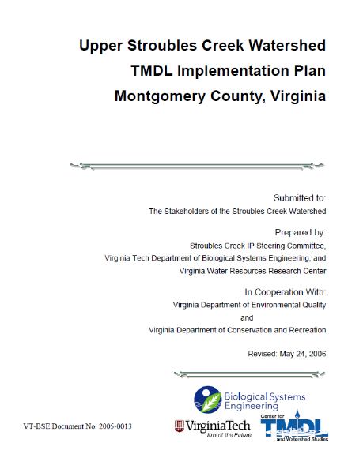
Following approval of a TMDL, various stakeholders may create an Implementation Plan (IP). Although such plans are alluded to in the Federal CWA legislation, they are not a specific requirement. However, such IPs are a state requirement through Virginia’s 1997 Water Quality Monitoring, Information, and Restoration Act. The Stroubles Creek IP was developed by the Stroubles Creek IP Steering Committee, Virginia Tech Department of Biological Systems Engineering (VT BSE), and the Virginia Water Resources Research Center in cooperation with the Virginia DEQ and Virginia Department of Conservation and Recreation (DCR). The Stroubles IP, entitled the Upper Stroubles Creek Watershed TMDL Implementation Plan Montgomery County, Virginia, is intended to contain actions that will be effective in reduction of sediment loads to Stroubles Creek, ultimately achieving reductions necessary to meet water quality standards.

The Stroubles Creek IP presents an implementation schedule for identified actions as measurable milestones. Scheduled actions specified for VT, along with the current implementation status, are listed in the Tables in Appendix A. As recognized in the Stroubles Creek IP, it is difficult to quantify load reductions achieved with the implementation of the identified actions in the IP. The status of each action indicates VT efforts to the MEP for consistency with the IP. The Action Plan presented herein will identify additional actions quantitatively, consistent with the MS4 GP to demonstrate VT’s plans to achieve the WLA.

MS4 Program Assessment
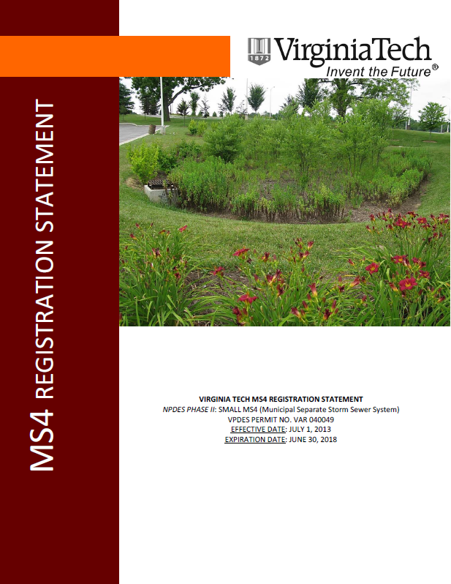
VT maintains compliance with the MS4 GP with implementation of BMPs defined in the VT MS4 Program Plan. A majority of the program BMPs can be considered nonstructural, in contrast to structural BMPs. Structural BMPs, such as retention ponds, capture pollutants after they have washed off the ground surface and been conveyed to the pond through stormwater runoff. Alternatively, nonstructural BMPs can be considered as “source controls” where the pollutant is either prevented from accumulating or is collected from the ground surface prior to exposure to precipitation that would convey the pollutant downstream. Source controls are typically performed at some defined frequency to minimize pollutant build-up and downstream wash-off during a rainfall event. Examples of nonstructural BMPs include community education programs, staff training, good housekeeping and pollution prevention procedures, catch basin cleanout, and street sweeping.

There is limited data available for quantifying the pollutant removal efficiencies of nonstructural BMPs. However, the limited research indicates significant reductions are achieved with a higher degree of cost effectiveness than with structural practices. Removal estimates for total suspended solids (TSS) are estimated to range from 30 – 70%.

Consistent with the special conditions described in Section 1.2, the following sub-sections characterize VT’s existing MS4 program in context of the Stroubles Creek TMDL POC, sediment.

MS4 General Permit Minimum Control Measures
VT maintains compliance with the MS4 GP through implementation of their VT MS4 Program that addresses the Minimum Control Measures (MCMs) outlined in the permit. Inherently, each is applicable to addressing reduction or elimination of sediment. Applicability is summarized as:
- MCM 1: VT has identified sediment as a high-priority water quality issue in the program’s Public Education and Outreach Plan (PEOP). As such, public education and outreach incorporates sediment concerns related to water quality in outreach to the identified target audiences, consisting of students, faculty and staff.
- MCM 2: Written procedures for public participation events are developed in conjunction with the PEOP and incorporate sediment as a water quality issue.
- MCM 3: VT conducts dry-weather outfall screenings for non-stormwater discharges, including sediment, and implements written procedures for detecting and eliminating identified discharges. VT has also conducted a campus assessment to identify potential sources of sediment. Where applicable per the permit, stormwater pollution prevention plans (SWPPPs) are developed to address potential pollutant discharges, including discharges of sediment. VT also disseminates information to the public for the reporting of illicit discharges. A prohibition of illicit discharges on the campus is established through the Illicit Discharge Detection and Elimination (IDDE) Policy (Policy).
- MCM 4: Regulated land disturbance projects on campus are required to be consistent with the VT Annual Standards and Specifications for erosion and sediment control (ESC) and stormwater management (SWM), which require approved plans that minimize sediment discharge from construction activity and post-construction. Inspections are required to be performed during construction activity and on any post-construction facilities built to address stormwater management.
- MCM5: The VT Annual Standards and Specifications for ESC and SWM require regulated land disturbance projects to address post-construction water quality. The MCM also requires a long-term inspection and maintenance program for stormwater management facilities to ensure functionality.
- MCM 6: VT developed good housekeeping procedures that are incorporated into staff training. The potential for discharge of sediment was included in the campus assessment to identify high priority facilities that will be targeted for site-specific SWPPPs.

Enhanced Public Outreach
VT’s MS4 program has enhanced public education and outreach and employee training programs to promote methods to eliminate or reduce the discharge of sediment from the MS4. Enhancement is described as follows:
- Public Education & Outreach Plan: The PEOP incorporated into VT’s MS4 Program Plan identifies sediment as a high priority water quality issue. The PEOP includes annual efforts to reach out to target audiences with information related to the Stroubles Creek TMDL, including methods to reduce the discharge of sediment. Examples of outreach opportunities regularly utilized by VT’s MS4 Program Plan include:
  - In-class guest speaker presentations to students on-campus
  - Steppin’ Out
  - VT Dining Table Cards and Dormitory Handouts
  - Earth Week and Sustainability Week events
  - Storm Drain Marking
  - The Big Event
  - ReNew the New
  - Stormwater Day – an event for middle school students

For further detail on the PEOP, VT’s MS4 Program Plan is available at:
https://www.facilities.vt.edu/content/dam/facilities_vt_edu/stormwater/program-plan-links-for-website/New%20Program%20Plan%202019.pdf

Facility Assessments and Identification of Significant Sources
VT has performed a campus-wide evaluation for the identification of areas that are significant and/or potential sources of sediment. The evaluation was consistent with the MS4 GP Special Condition Part II.B.3. Areas identified from the evaluation included isolated areas requiring stabilization or perimeter controls.

VT has also identified high priority areas as part of their MS4 Program consistent with Part I.E.6.c of the previous MS4 GP. The facilities are considered to have a high potential to discharge pollutants and site-specific SWPPPs have been developed to minimize pollutant discharges.

Additional detail on the facility assessments is available upon request from VT SID.

Waste Load Allocation
The Stroubles Creek TMDL assigns an aggregated WLA for permitted MS4s within the watershed that lumps MS4 discharges from VT, the Town of Blacksburg, and VDOT. The TMDL presents the WLA as an annual sediment load resulting from a “percent reduction” of the existing and projected future load from the MS4s to meet water quality standards. The percent reduction from the aggregated MS4 load is a 54% reduction of total future sediment loadings. A future date is not explicitly identified in the Stroubles Creek TMDL. However, future loadings are described as based on land use trends identified and projected by the Town of Blacksburg through 2046.

TMDL Model Approach
The Stroubles Creek TMDL describes a modeling approach that used the Toms Creek watershed in Blacksburg, Virginia, as part of a “reference watershed” approach since Toms Creek met the water quality standard. Each land use in the Tom’s Creek watershed was scaled by a factor of 1.19 for size-equivalent comparison to the Stroubles Creek watershed. The Generalized Watershed Loading Function (GWLF) computer model was used for comparative modeling using modeling parameters for each watershed. Hydrologic and sediment-related parameter values generally were selected from GWLF user manual guidance. No calibration of hydrologic parameters was performed. Loads were consolidated to be characterized from the following land uses: agriculture, non-MS4 regulated urban areas, forest, channel erosion, MS4s, and point sources regulated under VPDES permits. Loads from forested areas were not given load reductions in the Stroubles Creek TMDL, as is the norm, and instead reductions focused on anthropogenic sources of the POC. Since individual VPDES permitted discharges are already permitted, they also were not subject to further reductions. Table 1 summarizes the recommended sediment reductions to meet the target of the modeled reference watershed (accounting for a 10% MOS).

Table 1: TMDL Load Allocation from Stroubles Creek TMDL
Consolidated Source Category Land Use | TMDL Sediment Load Allocation (% reduction)
Agriculture | 77%
Urban (non-MS4 area) | 54%
Forest | 0%
Channel Erosion | 77%
MS4 | 54%
VPDES Point Sources | 0%

TMDL Model Land Use Data
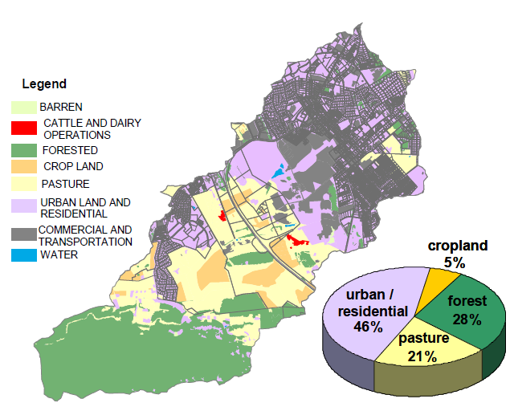
The Stroubles Creek TMDL model developed land use data using 1998 digital ortho-photo quarter quads, with the Stroubles Creek watershed developed by DCR and Toms Creek by VT BSE. Data was developed to delineate areas per land use and assigned a percentage of imperviousness per land use type. The four TMDL land use categories which included imperviousness were categorized as low, medium, and high density residential, and commercial. According to page 57 of the Stroubles Creek TMDL, the WLA was calculated as half of the modeled sediment load from impervious land uses within MS4 permit areas.
Land use in Stroubles Creek watershed, as presented in the Stroubles Creek TMDL.

Other Notable TMDL Model Parameters
GWLF is a continuous simulation model that uses daily time steps for weather data and water balance calculations. The daily rainfall data used was predominantly obtained from the National Weather Service station in Blacksburg (440766). The Stroubles Creek TMDL model used the Natural Resources Conservation Service (NRCS) Technical Release 55 curve number (CN) methodology for computing runoff. The CN values are determined using land cover type and the soils’ hydrologic soil group (HSG) classification, which indicates infiltration rates.

TMDL MS4 WLA Computations
TMDL loadings for MS4 areas were calculated in aggregate from impervious area loads within MS4 boundaries. Impervious area sediment loads were modeled explicitly in the GWLF model using an exponential buildup-washoff algorithm with sediment build-up assigned per land use as kg/ha-day. Both existing and future loads (see Table 2) were computed for MS4s and are described in the TMDL as:
- Existing (baseline) load (average loads from January 1985 through December 1994) - The MS4 loads were calculated for existing conditions and assumed to represent loads prior to implementation of MS4 regulations since MS4 programs were not yet implemented within the watershed.
- Future Conditions Load – Future loads for MS4s were based on an assessment that considered trends and future zoning plans (through 2046) for the Town of Blacksburg. The assessment resulted in projected changes in land use which were included in the model to calculate future loads. Changes generally show a decrease in forest and agriculture land use as urban area increases. Future load modeling (post-baseline loads) incorporates implementation of the MS4 program and credits the program with a 50% reduction of sediment loads.

According to the Stroubles Creek TMDL, the WLA was calculated as half of the modeled baseline sediment load from impervious land uses within MS4 permit areas, or 210.88 tons/year TSS. The difference in the WLA and future sediment load is a 54% reduction from the future load.

Table 2: Aggregated MS4 Loading Computations
Baseline Aggregated MS4 Sediment Load (tons/year) | Projected Future Aggregated MS4 Sediment Load (tons/year) | Aggregated MS4 Sediment WLA  (tons/year)
421.76 | 454.60 | 210.88

VT Disaggregated WLA
The TMDL-assigned WLA is aggregated for MS4s in the watershed, including VT, the Town of Blacksburg, and VDOT. Therefore, with the goal of achieving the WLA, it is necessary for VT to determine the proportion of the load appropriate for VT. Ideally, the proportion would be determined by the TMDL itself; however, since the WLA is aggregated, the “percent reduction” becomes the guiding target to achieve the WLA and a modeling effort is necessary to determine to the MEP the WLA proportion applicable to VT.

Watershed Treatment Model (WTM)
Since neither the Stroubles Creek TMDL model nor the land use data used in the model are available, VT estimated both the historic baseline load and projected future load using the Watershed Treatment Model (WTM) developed by the Center for Watershed Protection. The WTM has been recommended by DEQ for use with Action Plan development and is an effective tool for assessing pollutant loads and reductions, allowing for quantification of both structural and non-structural BMPs Additional information about the WTM is available at: http://www.cwp.org/online-watershed-library/cat_view/65-tools/91-watershed-treatment-model.

Computational Approach
The computational approach to estimate the VT MS4 sediment loadings with the WTM sought to follow an approach as consistent as possible with the Stroubles Creek TMDL model. The Stroubles Creek TMDL describes the loadings from MS4 areas as computed from impervious areas, as referenced below:
- “Future loads for the MS4 permits were calculated in aggregate from impervious area loads ...” (Stroubles Creek TMDL, Page 50)
- ‘’The waste load allocation (WLA) was calculated as half of the modeled sediment load [baseline load] from impervious land uses within MS4 permit areas …” (Stroubles Creek TMDL, Page 57)
- “The MS4 loads were calculated for existing conditions and assumed to represent loads prior to implementation of MS4 regulations.” (Stroubles Creek TMDL, Page 57)
- “Existing loads were modeled as if the MS4 permits and any accompanying BMPs were not active.” (Stroubles Creek TMDL, Page 50)
- “Existing MS4 loads were assumed to represent loads generated in areas covered by the MS4 permits prior to implementation of the Phase II MS4 regulations. The allocated MS4 load was based on the assumption that implementation of BMPs under the MS4 regulations to the “maximum extent practicable” would reduce existing loads by 50% and prevent any increases in the projected future scenario in Table 7.3 [454.6 tons/year TSS].” (Stroubles Creek TMDL, Page 59)

Based on the references listed above, the following determinations were made regarding the Stroubles Creek TMDL modeling for MS4 areas:
- Sediment loadings were computed from impervious land uses within the MS4 boundaries. These land uses are limited to residential (low, medium, and high density) and commercial areas in the TMDL (Stroubles Creek TMDL, Page 46).
- Existing (baseline) loadings were computed without MS4 programs considered in place within the MS4s.
- The WLA was established as 50% of the baseline load, with the assumption that the WLA would be achieved from the baseline based on MS4 implementation.
- The future aggregated MS4 load (454.6 tons/year) is a 7.8% increase from the existing aggregated MS4 load (421.76 tons/year). The MS4 program is considered in place for modeled future load; therefore, the increase represents reductions necessary in excess of those credited with MS4 implementation.

For consistency with the TMDL, each of the determinations are incorporated into the loading computations using the WTM and subsequent computations described in the following sub-sections.

Data Input to WTM
Data input into the WTM includes the following:
- Annual Rainfall: Consistent with the Stroubles Creek TMDL (Section 3.4), average annual rainfall at the National Weather Service Station in Blacksburg is 40.43 inches.
- Study area: Defined as the area of the Virginia Tech campus within the Stroubles Creek watershed, excluding areas covered under VPDES Industrial Stormwater Discharge permits.
  - The study area for the purpose of loading computations is also limited to land uses that include impervious cover (developed land uses), consistent with the TMDL. Although VT’s regulated MS4 area is technically only those areas discharging to the storm sewer system, the entire campus within the boundary is considered the study area for consistency with the TMDL. A map depicting the MS4 boundary within the TMDL watershed is provided in Appendix B.
- Land Use: Data used to classify the study area for the WTM was from the 2006 National Land Cover Dataset (NLCD), released on February 14, 2010. The data was the best readily available land use dataset to replicate the baseline condition with TMDL land use type consistency. The data set can be considered conservative since impervious areas likely increased from the study period. A map depicting the land use data in the study area is provided in Appendix C. VT reserves the right to re-compute loadings and required reductions in the case that more accurate historical land use data becomes available.
  - Imperviousness: The 2006 NLCD land use classification descriptions provide a range for the percentage of imperviousness for each land use. For the purposes of characterizing the study area, the middle value (e.g. a 35% value was used for a range of 20% to 49% imperviousness).

The VT Stroubles Creek WTM model is available upon request from VT SID and incorporated into this Action Plan, by reference. The model may be updated from time to time as more accurate data becomes available.

Computational Results for Required Reductions
Data input into the WTM resulted in an annual baseline sediment loading of 102.63 tons/year for VT’s MS4. The value computed by WTM represents approximately 25% of the aggregated WLA from the Stroubles Creek model for MS4s. The value appears appropriate based on visual inspection of the land use map on page 15 of the Stroubles Creek TMDL and the fraction of VT’s drainage area within the watershed. To determine the WLA, the following steps were taken:

- Recalling the WLA as half of the existing baseline load and that the baseline load did not consider BMP implementation. Therefore, the sediment WLA for VT is:

$$Disaggregated WLA= \frac{102.63 \frac{tons}{year}}{2}=51.32 tons/year$$

- The future load is computed as an increase in the baseline sediment load equivalent to the percent increase (7.8%) in the TMDL as:

$VT Future load= 102.63\frac{tons}{year}+\left(102.63\frac{ tons}{year}×0.078\right)=110.64 \frac{tons}{year}$
- The Stroubles Creek TMDL credits the MS4 program a 50% reduction from the baseline load. The reduction credited to the MS4 program is therefore 51.32 tons/year. The remaining sediment load is determined as:

$$Remaining load= 110.64\frac{tons}{year}-51.32\frac{tons}{year}=59.32 \frac{tons}{year}$$

- Therefore, the remaining reduction necessary to achieve the WLA is determined as:

$$Remaining req^{'}d reduction = 59.32\frac{tons}{year}-51.32\frac{tons}{year}=8.01 \frac{tons}{year}$$

With the continued implementation of the VT MS4 Program, additional reductions will be required to achieve a minimum of 8.01 tons/year of sediment to achieve the WLA under future conditions, as described in the TMDL.

Evaluated Methods to Achieve the WLA
VT has served as an active participant in efforts to address the impairments described in the Stroubles Creek TMDL through maintained compliance with the MS4 GP and with implementation of the BMPs described in the Stroubles Creek TMDL implementation plan. The TMDL explicitly credits the MS4 program with a 50% reduction from the baseline load. However, additional BMPs are required to achieve the remaining reduction necessary to meet the WLA.

A practice likely to provide significant sediment reductions is street sweeping. This practice is being recorded to have begun after the adoption of the Stroubles Creek TMDL and has been performed on an as-needed-based frequency. This effort is evaluated in the following sub-sections to assess its ability to achieve the remaining 8.01 tons/year of sediment reduction necessary to meet the WLA.

Street Sweeping
Source controls remove sediment from the land surface prior to its conveyance downstream. A source control such as street sweeping can be more cost-effective at a watershed scale than structural controls, such detention ponds, since larger surface areas can be addressed. VT has performed streets and parking lot sweeping on an as needed basis, such as before and after large sporting events. Part II.B.5.a of the MS4 GP requires the selection of implementation strategies to meet sediment reductions. Option two states, “one or more BMPs approved by the Chesapeake Bay Program (CBP).”

Sediment reduction calculations for street sweeping have been updated from previous Action Plan submittals to now match the guidelines in the Recommendations of the Expert Panel to Define Removal Rates for Street and Storm Drain Cleaning Practices final report approved by the CBP dated May 19, 2016 (referred to here as the Expert Panel Report). The Expert Panel Report recommended phasing out the previous methods of calculating sediment reduction from street sweeping in favor of the lane-mile based approach reflected in Table 3.

In lieu of the mass loading approach to quantify reductions, although not required by non-Chesapeake Bay MS4s, VT will be using the lane mile approach from 2016 Expert Panel Report. The information in Table 3 indicates the mileage required to be swept annually per street sweeping practice in order to meet the sediment reduction required (8.01 tons/year or 16,020 lbs./year) for future sediment loads towards achieving the WLA.

Table 3: Estimate of Sediment Removal by Sweeping Using the Lane Mile Approach

 | Virginia Tech required TSS TMDL WLA Reductions |  |  |  | Approximate Minimum Lane Miles or Acres/Yr. | Approx. Minimum Lane Miles or Acres to Sweep/Pass
 | Street Cleaning Practices Available for Credit |  |  | Removal Rate
 | Practice | Description* | Passes/Yr. | TSS
Advanced Sweeping Technology | SCP-1 | 2 passes per week | 100 | 0.21 | 59 | 0.59
 | SCP-2 | 1 pass per week | 50 | 0.16 | 78 | 1.56
 | SCP-3 | 1 pass per 2 weeks | 25 | 0.11 | 113 | 4.52
 | SCP-4 | 1 pass every 4 weeks | 10 | 0.06 | 206 | 20.60
 | SCP-5 | 1 pass every 8 weeks | 6 | 0.04 | 309 | 51.50
 | SCP-6 | 1 pass every 12 weeks | 4 | 0.02 | 617 | 154.25
 | SCP-7 | Seasonal scenario 1 or 2 | 15 | 0.07 | 177 | 11.80
 | SCP-8 | Seasonal scenario 3 or 4 | 20 | 0.1 | 124 | 6.20
Mechanical Broom Technology | SCP-9 | 2 passes per week | 100 | 0.01 | 1,233 | 12.33
 | SCP-10 | 1 pass per week | 50 | 0.005 | 2,465 | 49.30
 | SCP-11 | 1 pass every 4 weeks | 10 | 0.001 | 12,323 | 1,232.30
*Seasonal scenarios are defined as follows:
S1: Spring - One pass every week from March to April. Monthly otherwise.
S2: Spring - One pass every other week from March to April. Monthly otherwise.
S3: Spring and fall - One pass every week (March to April, October to November) Monthly otherwise.
S4: Spring and fall - One pass every other week during the season. Monthly otherwise.
Notes:
(1) The standard street cleaning unit is the number of curb miles swept. One impervious acre is equivalent to one curb-lane mile swept assuming swept on one side only.
(2) Acres of parking lot swept are converted to lane miles using one acre = one curb lane mile.
(3) Loading Rates associated with urban impervious cover in the Chesapeake Bay Watershed.
Average TN Load |  | 15.5 lbs/ac/yr
Average TP Load |  | 1.93 lbs/ac/yr
Average TSS Load |  | 1,300 lbs/ac/yr

Action Plan
A determination of the disaggregated WLA for VT and evaluation of the current activities to reduce sediment loads finds that street sweeping alone is able to achieve the Stroubles Creek TMDL WLA. For planning purposes, an estimated “end date” for achieving the WLA will be June 30, 2070.

Progress Reporting
Street sweeping efforts will follow a schedule to show progress towards meeting the WLA by the end date. The following are the action steps included in the schedule:
- Determine miles swept potential of campus. Select a practice to implement from Table 3 of this report.
- Develop improved tracking documentation and training materials. Conduct training.
- Assess numerical progress towards meeting the WLA.
- Assess the effectiveness of VT’s sweepers and consider future sweeper purchases. The current sweeper in use includes:
  - A Tennant Centurion which is vacuum assisted for dry dust suppression and provides 4 cubic yards of material volume.
- Re-evaluate program the last year of every permit cycle to ensure progress towards meeting the WLA reduction by June 30, 2070.

The action steps in the schedule are intended to serve as a defined method that inherently acts as an adaptive iterative approach to ultimately achieve the WLA.

Progress Reporting
Progress will be reported annually by October 1st in the MS4 Annual Report using the accounting methods outlined in Section 4 and recording miles swept using the practices outlined in Table 3.

Schedule
Since the approval of the Stroubles Creek TMDL, VT has made significant progress in the reduction of sediment loads from its MS4. These reductions are demonstrated qualitatively in the MS4 Program assessment described in Section 2 and with the status summary of measurable milestones listed in the Stroubles Creek Implementation Plan (Appendix A). Additional reductions are quantified from street sweeping efforts as described in Section 4.1. Table 4 summarizes the schedule for completion of the Action Plan Street Sweeping Program steps described in Section 5.1 as VT continues moving forward to achieve the remaining necessary reductions to achieve the WLA.

Table 4: Schedule for the VT Stroubles Creek TMDL Action Plan Street Sweeping Program
Step | General Description | Measurable Goal | Completion  Date
1 | Transition to Lane Mile Approach | Determine miles swept potential of campus. Select a practice to implement from Table 3 of this report. | June 30, 2020
2 | Improve tracking on areas swept and begin training for staff | Develop improved tracking documentation and training materials. Conduct training. | June 30, 2021
3 | Evaluate Street Sweeping Program | Assess numerical progress towards meeting the WLA. | June 30, 2022
4 | Sweeper evaluation and purchase | Assess the effectiveness of VT’s sweepers and consider future sweeper purchases. | June 30, 2023
5 | Re-evaluate Street Sweeping Program | Re-evaluate program the last year of every permit cycle to ensure progress towards meeting the WLA reduction by June 30, 2070. | June 30, 2024

The Street Sweeping Program described in Table 4 will serve as the primary activities to achieve sediment reductions.

References

Bateman, M. 2012. Methodology for calculating nutrient reductions using the FSA assessment tool. Florida Stormwater Association and Florida Department of Environmental Protection.

Street and storm drain cleaning expert panel. 2016. Recommendations of the expert panel to define removal rates for street and storm drain cleaning practices. Final Report approved by CBP Management Board.

VA DEQ. 2015. Chesapeake Bay TMDL Special Condition Guidance. Guidance Memo 15-2005.

VA DEQ and VA DCR. 2003. Benthic TMDL for Stroubles Creek in Montgomery County, Virginia.

VA DEQ and VA DCR. 2006. Upper Stroubles Creek Watershed TMDL Implementation Plan, Montgomery County, Virginia.

Appendix A: Stroubles Creek IP BMP Accomplishments

Table 1: Measurable milestones listed for Virginia Tech in the Stroubles Creek IP and subsequent action taken.
Actions (2006 – 2010)
Measurable Milestone | Action Taken
Assess capacity of culverts at Route 460. | Campus-wide stormwater model/analysis in progress.
Develop an official Adopt-A-Stream program for service organizations on campus. | Virginia Tech manages a 1.2-mile portion of Stroubles Creek through the Adopt-A-Stream Program. This is an ongoing effort.
Upgrade sanitary sewer line from Prices Fork Road to West Campus Drive. | The sewer line was replaced under a 3 part agreement between the Town, Sanitation Authority and Virginia Tech.
Plan, install, and monitor demonstration water quality, LID, and other innovative storm water management practices. | Virginia Tech has installed several stormwater BMPs that are inspected on a scheduled basis.
Arrange for external review and evaluation of the E&S Program as implemented in the watershed. | An internal audit by an outside consultant was conducted in 2012.
Calibrate the water, storm, and sanitary sewer models for campus for analysis of water consumption and discharge. | A water model has been developed and is updated as needed.
Link GIS mapping capabilities with discharge model to track illicit discharges and scheduled maintenance for storm water facilities. | Virginia Tech implemented an Infiltration & Inflow study in 2008 and tracks illicit discharges in GIS.
Construct a combined salt storage facility with TOB to prevent runoff. | A combined salt storage facility was established in 2008.

Appendix B: Virginia Tech MS4 Boundary within the TMDL Watershed

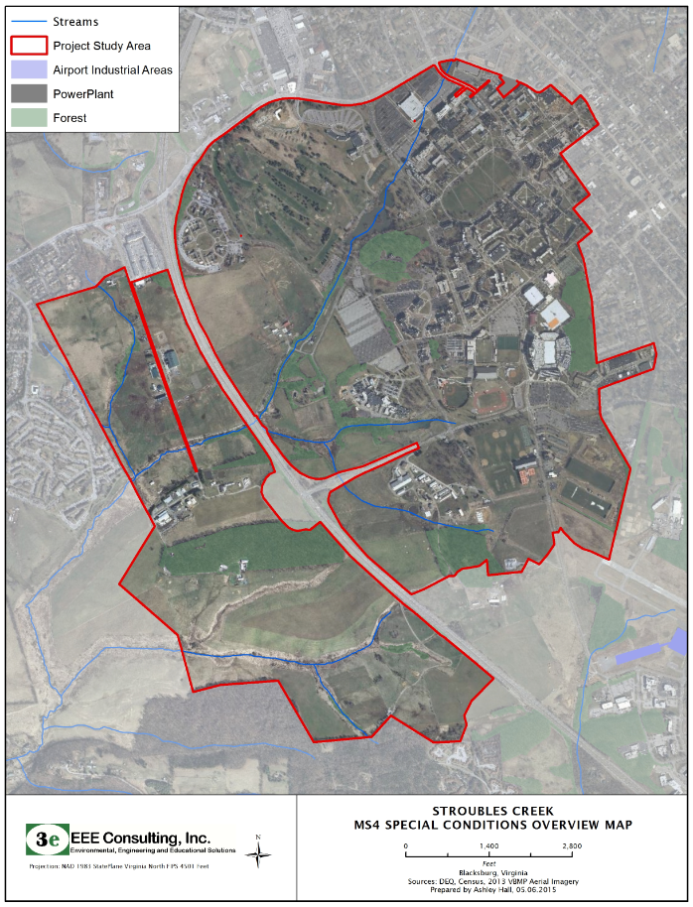

Appendix C: Land Use Map Used for WTM Input

