GREEN RFP SUBMISSION FORM

Part I- General Information:
Name of Student Organization |  | UAP-3354 Introduction to Environmental Policy and Planning
Contact/Responsible Person |  | Kevin Bayne
Contact Office Held/Title
Contact Email Address |  | Baynekr01@vt.edu
Contact Telephone Number |  | (607)-483-7307
Part II- Project Cost Information
Estimated Cost of this Proposal |  | $14850 | See III.C. below
Estimated Savings - |  | $0 | See III.D. below
Net Cost of this Proposal = |  | $14850
Part III- Supporting Information

- Please describe your climate action, sustainability, and/or energy initiative and attach supporting documentation.

The proposal is to add two native flower gardens in the roundabouts located on the eastern side of the Drill Field located by Torgersen Hall and Newman Library. These two symmetrical circular gardens would be planted to benefit the pollinators, carbon footprint, and stormwater management of campus. The location of the gardens are indicated in the figures below.
Both of the circular gardens would have a radius of 25 feet, giving each of them an area of 1963 feet squared. Only native plant species would be planted in the gardens. With the increase in plant biomass and root systems, more stormwater will be retained and filtered instead of flowing onto the impervious surfaces and then the drainage system. Furthermore, with the increase in plant biomass, more carbon can be sequestered from the surrounding area and help aid in the reduction of the carbon footprint of campus.

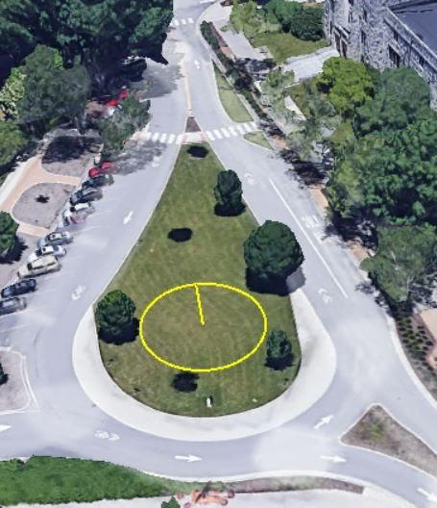
(Figure 1: Roundabout located next to Newman Library)
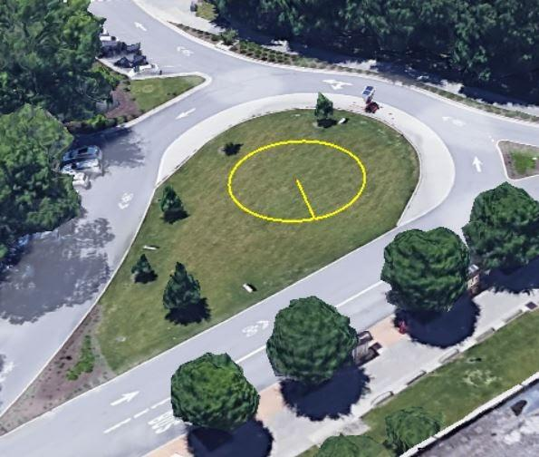
(Figure 2: Roundabout located next to Torgersen Hall)

- How does this initiative help to achieve the goals of the Virginia Tech 2020 Climate Action Commitment Resolution and Sustainability Plan?

Through the implementation of Native Flower Gardens, the increase of plant biomass will sequester more carbon from the atmosphere than if the roundabouts were left as just grass. This action directly correlates to the plan to become a carbon neutral campus by 2030. Moreover, the gardens can also allow for educational opportunities regarding the benefits of having native vegetation and pollinators incorporated into urban areas.

Attachment # 2
- What is the cost of your proposal? Please describe in adequate detail the basis for your cost estimate.

Updated costs of plants and site prep with 10% contingency.
250 shrubs @ $50 = $12,500 (using contract labor)
Mulch = $1,000
10% Contingency = $1,350
Total = $14,850

- Will your proposal produce cost savings for the university? If so, how much? Please describe in adequate detail the basis for your savings estimate.

This proposal does not produce cost savings for the university, but it does provide many other benefits for both the community and environment. By planting perennial native plants, we would be growing vegetation that is already adapted to the environment and that require very little time and money to continue their care since those plants naturally have life spans of over two years. Native plants do not require fertilizers, and they require less pesticides, providing a safe space for shelter for small animals. These plants also provide nectar, seeds, and pollen that serve as food for insects, butterflies, birds, and other animals. Native plants have natural protections, making them resistant to common pests and diseases. Bigger native plants also hold more rainwater, compared to simple grassy areas, which will lead to less runoff and less water in the sewage systems. They would also control erosion by reducing land degradation and salinity. Native plants have deep root systems which allows them to store more carbon, reducing greenhouse gas emissions and global warming. As an added benefit, this proposal provides biodiversity to our ecosystem and adds scenic value to the community.

- Is this funding request for a one-time need or an ongoing need (please mark one)?

One-Time _X____ Ongoing _____

- Is funding available for this request from another source? If yes, describe the funding (source, amount, etc.).

No, funding in not available from another source

GREEN RFP SUBMISSION FORM
(Continued)

Part IV- Requestors/Reviewers
Kevin Bayne, Haley Bautista, and Jennie Weitzenhofer  Prepared By (Name of Contact for Student Organization) |  | Date 11/10/2021
Jack Rosenberger  Matt Gart  Reviewed By (Name of Appropriate University Official)  Nathan King  Reviewed By (Name of Office of Climate Action, Sustainability, and Energy Representative) |  | 12/7/21  Date  12/3/21  Date

GREEN RFP SUBMISSION
CONTACT LIST

In the preparation of your Green RFP form, student organizations are encouraged to seek input and guidance from the following list of university employees. These individuals are familiar with the form and the process. They can address the feasibility of your proposal, provide a technical review, and evaluate the cost & potential savings.

Area of Expertise | Name | Title | Email Address
Engineering & Operations, Energy Management | Steve Durfee | Campus Energy Manager | sdurfee@vt.edu
Facilities: Housing & Residence Life | Todd Pignataro | Associate Director of Facilities | ptodd@vt.edu
Facilities: Buildings & Grounds (Small Renovations) | Jim McDaniel | Project Coordinator | jmcdani@vt.edu
Exterior Lighting | Matt Hagy | Associate Director of Utilities | mhagy1@vt.edu
Student Engagement & Campus Life | Spencer Stidd | Associate Director for Event Services | sstidd@vt.edu
Dining Services & Housing (Student Affairs) | Blake Bensman | Sustainability Manager | bensman@vt.edu
Alternative Transportation (Bus, Bike, & Walk/EVs) | Nick Quint | Transportation Network Manager | nquint@vt.edu
Landscape Architecture | Jack Rosenberger | Campus Landscape Architect | jrosenb@vt.edu
Hahn Horticulture Garden | Scott Douglas | Director/Instructor | dsd1@vt.edu
Recycling & Waste Management | Teresa Sweeney | Program Consultant | msrecycle247@vt.edu
Other Sustainability Topics | Nathan King | Campus Sustainability Manager | naking@vt.edu

