GREEN RFP SUBMISSION FORM

Part I- General Information:
Name of Student Organization |  | GUAPA
Contact/Responsible Person |  | Cat Woodson
Contact Office Held/Title |  | Member
Contact Email Address |  | cat412@vt.edu
Contact Telephone Number |  | (412) 737 – 8715
Part II- Project Cost Information
Estimated Cost of this Proposal |  | $100,000 | See III.C. below
Estimated Savings - |  | $0 over one academic year | See III.D. below
Net Cost of this Proposal = |  | $100,000 over one academic year
Part III- Supporting Information

- Please describe your climate action, sustainability, and/or energy initiative and attach supporting documentation.

Our sustainability initiative is focused on promoting alternative transportation modes, particularly bikes, on the Virginia Tech campus. With the campus opening up again to in person classes and on campus living, there has been an influx of on campus activity. Additionally, now that Blacksburg Transit has lifted their capacity limitations, many busses are filled to or above capacity with passengers. A more viable option for commuting without relying on SOVs is promoting, facilitating, and encouraging bicycling on campus.

As part of a current research project to identify influences on decisions and behavior of VT students, faculty and staff related to alternative transportation multiple focus groups with VT students, faculty and staff members were conducted by a Virginia Tech research team (VTTI, Alternative Transportation, Population Health Sciences). Six of the focus groups were with students and included 5 or more participants. Expressed in these focus groups was a need for more covered bike racks.

With this in mind, we propose adding more covered bike racks at locations on campus as identified in the Bike Parking Master Plan. Our proposal includes adding covered bike racks at the dorms that are currently without. The bike rack covers Virginia Tech uses only come in one size. They fit nicely over an 8-loop rack. Some residence halls do not currently have any racks of this size, so our proposal includes a rack for these instances. The table below details the proposed covers and racks.

Residence Hall | Proposed Covered Racks
Hillcrest | One cover and one 8-loop rack
Newman | One cover and one 8-loop rack
Hoge | One cover and one 8-loop rack
Payne | One cover

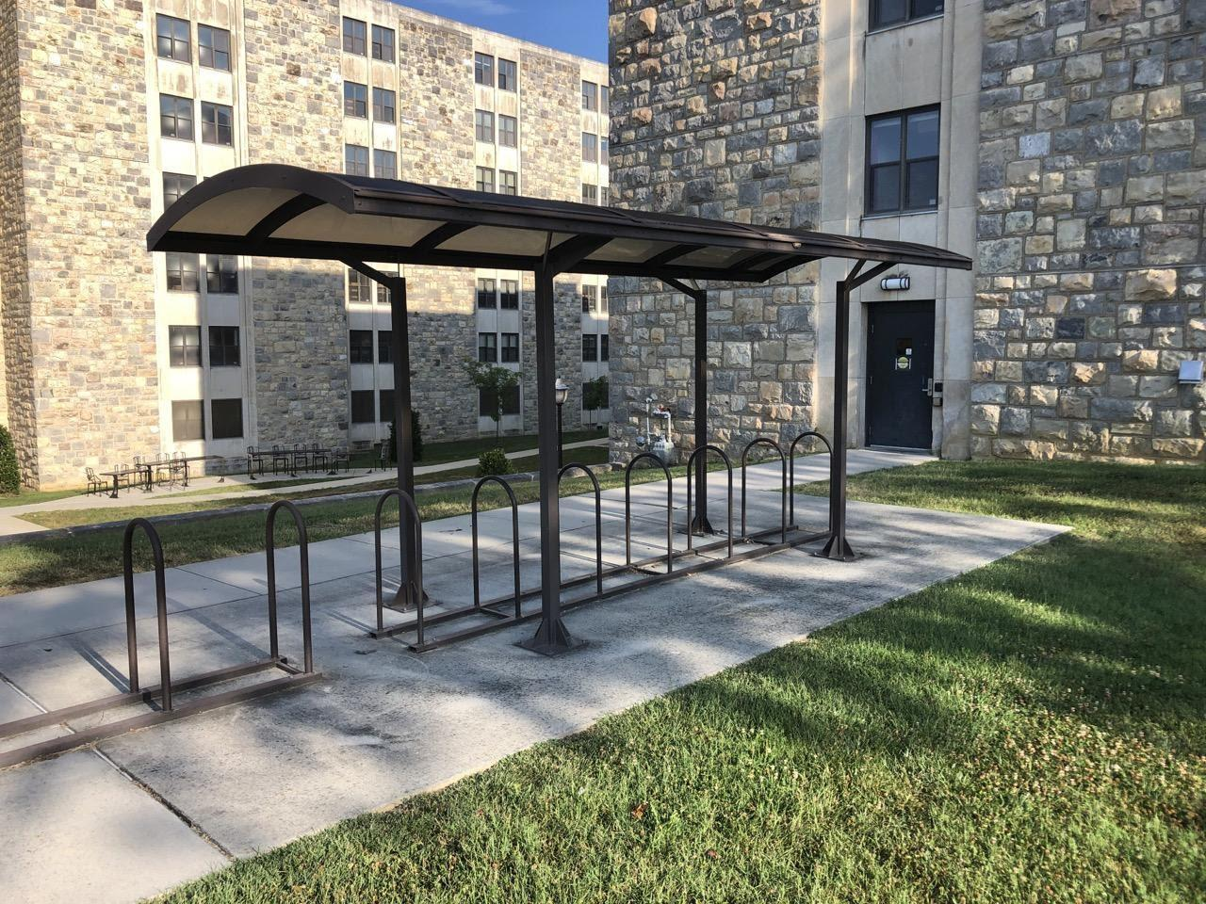
Example of a covered bike rack at Ambler Johnston Hall

The installation of these additional covered bike racks will encourage more students to use bikes as a primary mode of transportation, therefore relieving some of the stress on transit. It will also incentivize students to bike rather than drive to campus, helping reduce emissions and alleviate traffic congestion during class changes.
- How does this initiative help to achieve the goals of the Virginia Tech 2020 Climate Action Commitment Resolution and Sustainability Plan?

2020 CAC Goal 9. Reduce Single-Occupancy Vehicle (SOV) Commuting to Campus by 20% by 2025 and Reduce Transportation-Related GHG Emissions by 40% by 2030

Highlighting Potential Pathways:
- Promote walking/biking/transit as the preferred means of commuting to campus: use parking policies, alternative transportation programs, campus mobility planning in collaboration with Town of Blacksburg, and encourage Blacksburg Transit (BT) programs to improve the safety and convenience of and promote walking/biking/transit
- Improve infrastructure and traffic management to improve mobility choices and safety by reducing speed limits, improved bike/ped path lighting, limiting/restricting vehicles in core campus, implementing current transportation plans, and coordinating with Town of Blacksburg plans Improve vehicle efficiency and promote low-carbon emissions vehicles through Motor Pool purchases and development of electric vehicle charging stations on campus
- Reduce and negate business travel GHG emissions with carbon offsets

2020 CAC Goal 12. Diminish Barriers to Sustainable Behaviors through Institutional Change, Education and Social Marketing

Highlighting Potential Pathways:
- Identify structural, social and institutional barriers to sustainable behaviors ES-10

One of the greatest challenges in using a bicycle as a primary mode of transportation is the issue of storing it while it is not in use and protecting it against hash weather conditions. Additional, easy-to-access bike racks in high traffic areas with covering will encourage bicycle use. More students will be empowered and encouraged to commit to riding bicycles rather than driving.
Adding covered bike racks shows that Virginia Tech recognizes the importance of zero-emission transportation as an important aspect of environmental sustainability. Biking is also economically sustainable and affordable because students do not have to pay for fuel or insurance. Finally, it will help improve Virginia Tech’s status as a Bicycle Friendly University, a national program that “recognizes institutions of higher education for promoting and providing a more bikeable campus for students, staff, [faculty] and visitors.” Encouraging students to choose a zero-emission transportation mode such as bicycling reduces emissions, traffic congestion, and associated parking problems.

- What is the cost of your proposal? Please describe in adequate detail the basis for your cost estimate.

ITEM DESCRIPTION | UNIT COST | QUANTITY | TOTAL COST
Bike rack cover | $14,000 | 4 | $56,000
Concrete pad | $2,000 | 4 | $8,000
Installation | $5,650 |  | $22,600
Landscaping | $500 | 4 | $2,000
Contingency (~10%) |  |  | $11,400
Total |  |  | $100,000

- Will your proposal produce cost savings for the university? If so, how much? Please describe in adequate detail the basis for your savings estimate.

Indirect cost savings for the University would include savings from less money being spent on building and maintaining parking lots. Biking also has numerous physical and mental health benefits, which would lead to fewer sick days and an increase in productivity. Bike rack covers are made to withstand weathered conditions, which would save costs by not having to replace bike racks as soon or often.

- Is this funding request for a one-time need or an ongoing need (please mark one)?

One-Time X Ongoing _____

- Is funding available for this request from another source? If yes, describe the funding (source, amount, etc.). No.

GREEN RFP SUBMISSION FORM
(Continued)

Part IV- Requestors/Reviewers
Prepared By (Name of Contact for Student Organization) Cat Woodson |  | Date 11/17/2021
Reviewed By (Name of Appropriate University Official) Nick Quint  Nathan King  Reviewed By (Name of Office of Climate Action, Sustainability, and Energy Representative) |  | Date 11/18/2021  Date 12/2/21

